Week 3: Advanced Security

Intern Name: | Ayesha
Organization: | DevelopersHub Corporation
Internship Domain: | Cybersecurity
Report Week: | Week 3
Submission Date: | June 2, 2026
GitHub: | github.com/aisha-cybersec/developershub-cybersecurity-internship

1. Introduction
This report tell the tasks, I completed during Week 3 of the DevelopersHub Corporation Cybersecurity Internship Program. The focus of Week 3 was on implementing security logging and monitoring using the Winston library, performing network port scanning using Nmap, and completing a comprehensive security checklist for the OWASP Juice Shop application.

2. Task 1 : Winston Logger Installation & Implementation
2.1 Winston Installation
Command executed to install Winston:
npm install winston
Winston installation and application startup:
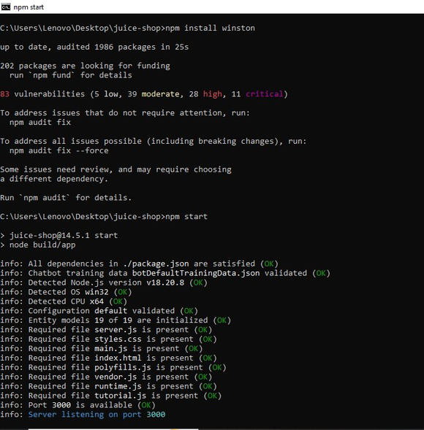

Figure 1: npm install winston successfully completed, app running on port 3000

2.2 logger.js Implementation
A dedicated logger.js file was created in the project root with the following configuration:
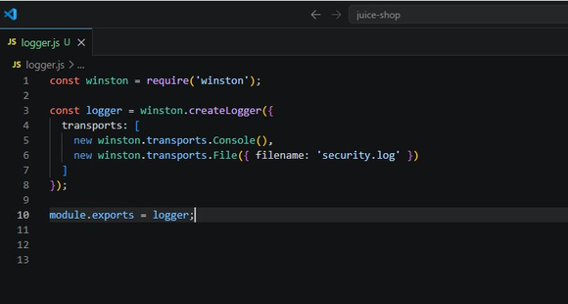
Figure 2: logger.js Winston logger with Console and File transports
The logger.js file configures two transports:
- Console Transport: Outputs logs to terminal in real time for developer monitoring
- File Transport (security.log): Persists all security logs to disk for audit purposes

2.3 Server Integration
The logger was integrated into the main server.ts file of the OWASP Juice Shop application. The logger was imported and used to log application startup events:
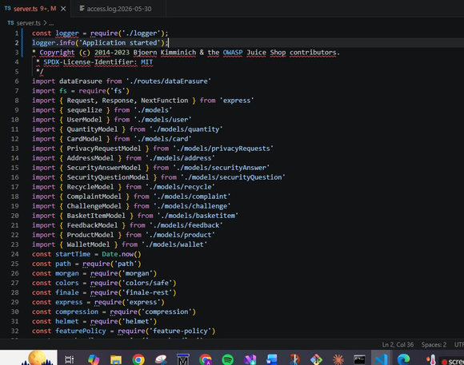
Figure 3: server.ts Logger imported and logger.info("Application started") added

2.4 Application Running Successfully
After integrating the logger, the application was started using npm start. All dependencies were satisfied and the server started successfully on port 3000:

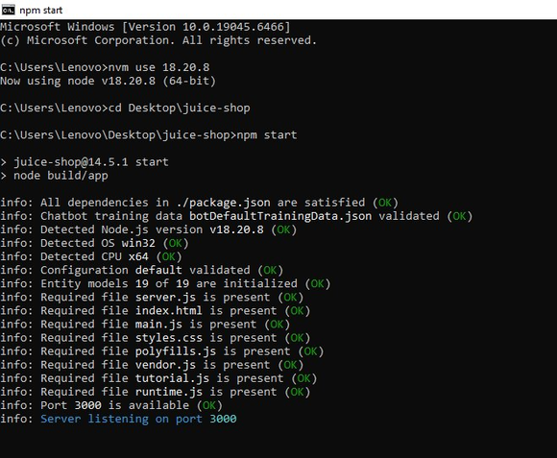

Figure 4: npm start : Server listening on port 3000 with all files OK

3. Task 2 : Network Port Scanning with Nmap

3.1 What is Nmap?
Nmap (Network Mapper) is an open-source network scanning tool used by security professionals to discover hosts and services on a network. It is a fundamental tool in cybersecurity for:
- Port scanning identifying open, closed, or filtered ports
- Service detection identifying software and version running on each port
- Vulnerability assessment finding exposed attack surfaces

3.2 Tool Details
Property | Details
Tool Name | Nmap (Network Mapper)
Version | Nmap 7.99
Platform | Windows (i686-pc-windows)
Target | localhost (127.0.0.1)
Port Scanned | 3000/tcp
Scan Type | Service Version Detection (-sV)
Command Used | nmap -sV -p 3000 localhost

3.3 Nmap Scan Execution
The following command was executed in Command Prompt with the application running on port 3000:
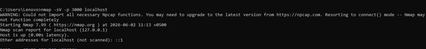
Figure 5: nmap -sV -p 3000 localhost Scan command executed

3.4 Port Scan Results
The scan identified port 3000 as OPEN with the Node.js/Express application running:
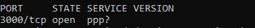
Figure 6: PORT 3000/tcp open Port status confirmed
Full scan output with HTTP fingerprint data:
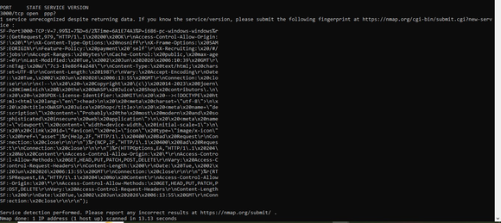
Figure 7: Complete Nmap scan results OWASP Juice Shop fingerprint detected

3.5 Scan Analysis
Port | State | Service | Finding
3000/tcp | OPEN | HTTP (Node.js) | OWASP Juice Shop running — expected open port

Key findings from the scan:
- Host Status: UP with 0.00s latency application is responsive
- Port 3000: OPEN OWASP Juice Shop running as expected on this port
- HTTP Headers Detected: Access-Control-Allow-Origin, X-Frame-Options, Feature-Policy, X-Content-Type-Options
- No unexpected ports open attack surface is minimal

4. Task 3 Security Checklist

4.1 Week 1 Vulnerability Assessment
Security Task | Status | Risk Level
OWASP Juice Shop setup and running | DONE | —
SQL Injection vulnerability tested | DONE | CRITICAL
XSS (Cross-Site Scripting) tested | DONE | HIGH
OWASP ZAP automated scan completed | DONE | MEDIUM
Vulnerability report uploaded to GitHub | DONE | —

4.2 Week 2 Security Implementation
Security Task | Status | Package
Input validation implemented | DONE | validator
Password hashing with bcrypt (salt=10) | DONE | bcrypt
JWT token authentication configured | DONE | jsonwebtoken
HTTP security headers added | DONE | helmet
security.js file created with all fixes | DONE | —
All security tests passing | DONE | —

4.3 Week 3 Logging, Monitoring & Audit
Security Task | Status | Tool
Winston logging library installed | DONE | winston
logger.js created with Console + File transport | DONE | winston
Logger integrated into server.ts | DONE | winston
Nmap installed (v7.99) | DONE | Nmap
Port scan on localhost:3000 completed | DONE | Nmap
Scan results saved to nmap_scan_results.txt | DONE | Nmap
Security checklist created | DONE | —
Week 3 report written with screenshots | DONE | —

WEEK 3 ASSESSMENET COMPLETE

